Name:- Saksham Pathak

Enrollment Number:- 09914803119

EXPERIMENT 3:- LAB 2 DBMS

SQL Statements for Implementing ALTER UPDATE and DELETE;

1)cmd: CREATE DATABASE Office;

2)cmd: Use Office;

3)cmd: CREATE TABLE Employee(id int NOT NULL,Name varchar(255),Role varchar(255),PRIMARY KEY (id));

4)cmd: INSERT INTO Employee(id,Name,Role)VALUES ('1','Elliot alderson','Consulting Hacker');

5)cmd: INSERT INTO Employee(id,Name,Role)VALUES ('2','saksham pathak','Systems Arch');

6)cmd: Select \* FROM Employee;

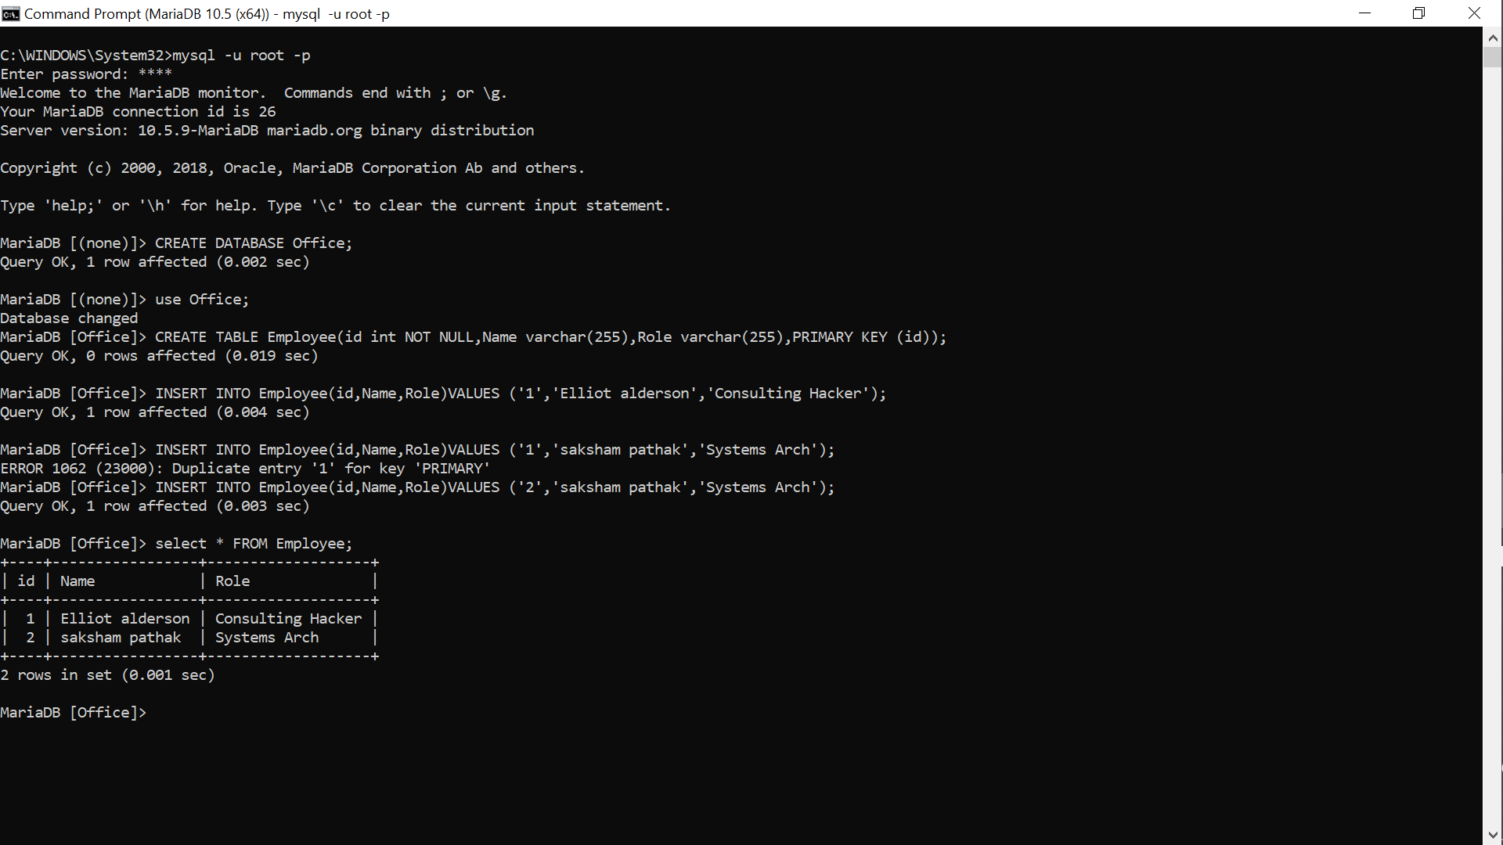

7)cmd: ALTER TABLE Employee ADD COLUMN Salary int NOT NULL;

8)cmd: Select \* FROM Employee;

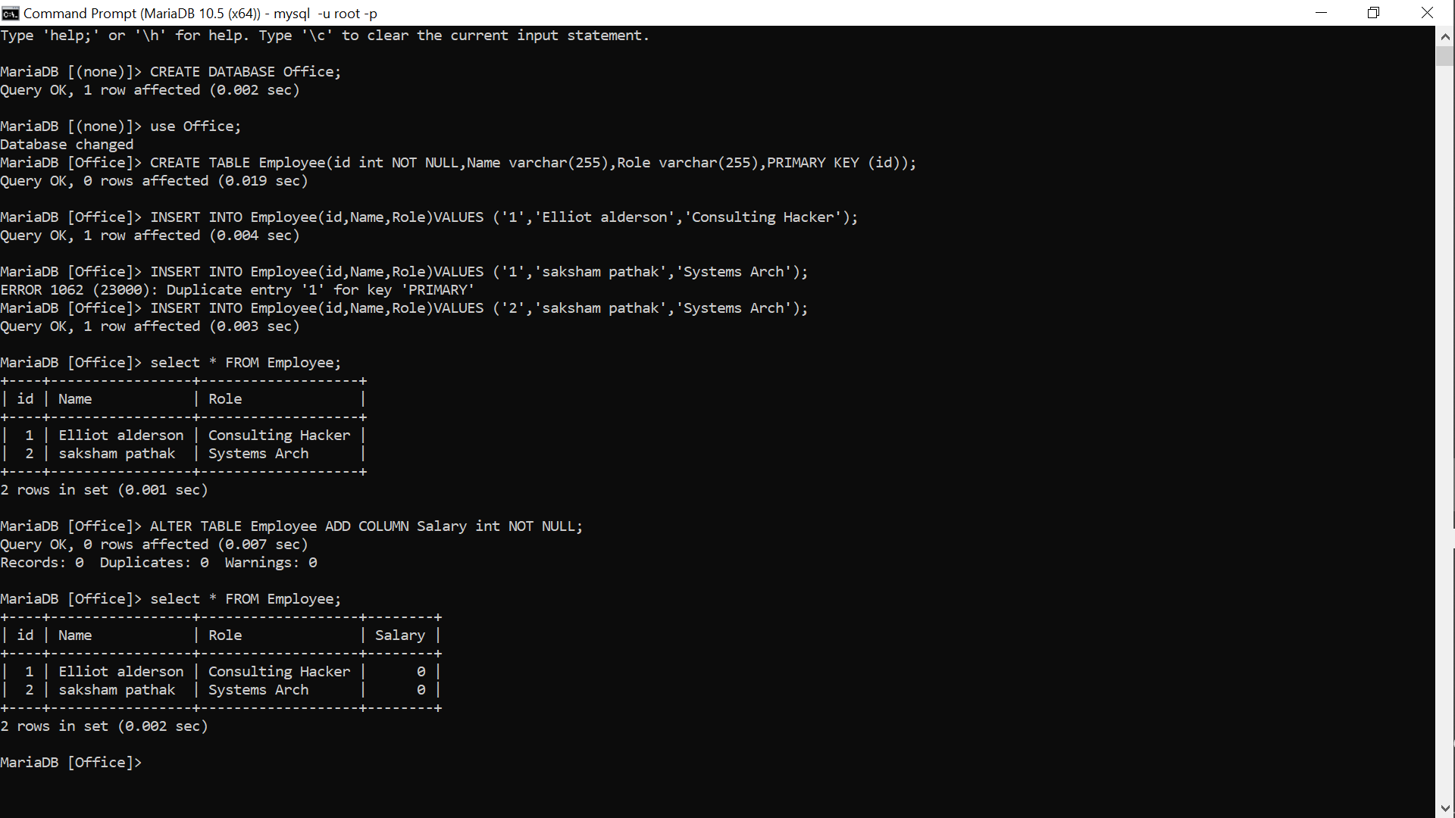

9)cmd: UPDATE Employee SET salary = '15000' WHERE id = '1';

10)cmd: UPDATE Employee SET salary = '10000' WHERE id = '2';

11)cmd: Select \* FROM Employee;

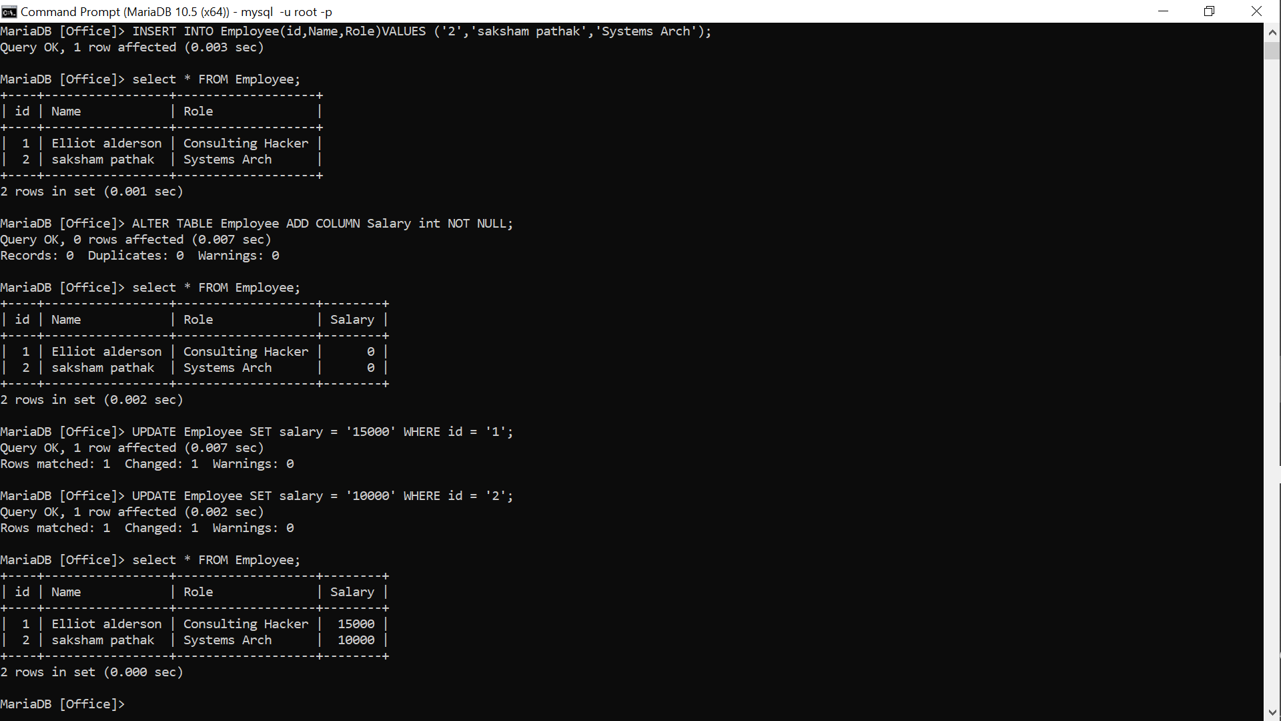

12)cmd: DELETE FROM Employee WHERE Name = 'saksham pathak';

13)cmd: Select \* FROM Employee;

